**Virginia Motorsports Technology Committee**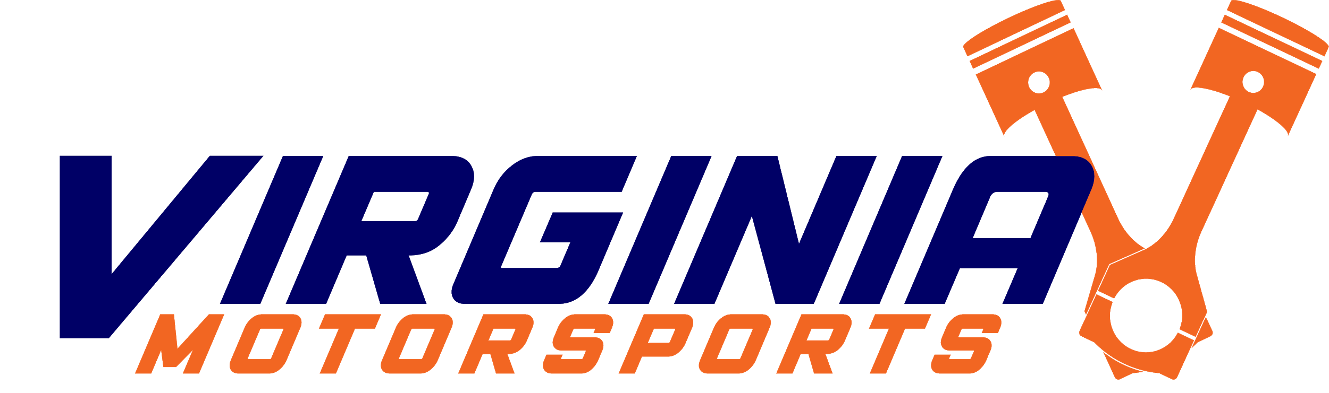

Meeting Agenda & Minutes

*Date and Time*: 3/4/2021, 4 PM

*Next meeting*:

**Agenda**

1. Discussion & Other Topics
   1. Tasks
      1. **Inventorying (Vishal)**
         1. Labels are done, need to make more labels
         2. Document how to make labels as well
         3. **Friday, March 5th @ 4 PM to go in and label stuff**
      2. Repairing the Drone (**Ian**)
         1. Fixed!!
      3. Documentation server for (F)(B)SAE (**Daniel/Ian**)
         1. <https://drive.google.com/drive/u/1/folders/1qwrWyGgBfoQFp-Ki8S_G30EEWB74GGd6>
         2. Research AWS and Mediawiki
            1. Maybe see if it’s been done before
      4. Public website updates (**Daniel**)
         1. Update FSAE Page
            1. See: formula 2020-2021 drive folder
         2. Add alumni jobs page
            1. Ask blake g for alumni data
            2. See: alumni 2020-2021 drive folder
            3. <https://drive.google.com/drive/folders/1lAmWSBmJJi_L-3e6Hd5OTeyYWY6k2i_G?usp=sharing>
   2. Purchase things ideas
      1. RGB for shelving or one of our competition cars
      2. SSDs?